PLEASE DOWNLOAD OR SAVE A COPY PRIOR TO COMPLETING

Under the “File” menu above, select “Save as Google Docs” or “Download”

CUSTOMER DISCOVERY



101 WORKBOOK

Companion to the Customer Discovery 101 Program

[customerdiscovery101.launchbox.psu.edu](https://customerdiscovery101.launchbox.psu.edu/)

# How to use this workbook

This workbook accompanies the [Customer Discovery 101 Program](https://customerdiscovery101.launchbox.psu.edu/) and is designed to be used as you move through the online program. As you work through the program, you will be prompted to complete specific templates in this workbook.

We recommend you download a copy of this workbook before beginning the Customer Discovery 101 program, but you will find hyperlinks to the workbook throughout the online program to download later.

A key part of this program is working with a coach as you complete each step. If you don’t have access to a business coach, contact [customerdiscovery@psu.edu](mailto:customerdiscovery@psu.edu) to learn how Invent Penn State’s LaunchBox & Innovation Network can help you find one.

To get started:

1. Download the workbook to your device.
2. Complete the workbook in Microsoft Word or another word processing program, or print out the workbook and complete by hand.

Open hyperlinks throughout the document by pressing the Ctrl button while clicking on the link.

Interested in doing customer discovery in a group or class setting? [Consider joining an *Idea*](mailto:customerdiscovery@psu.edu) *TestLab* accelerator program, offered by most LaunchBoxes and innovation spaces in the Invent Penn State Network (see example [here](https://happyvalley.launchbox.psu.edu/idea-testlab/)). Contact your local innovation space or email to learn more.

For questions about the program or workbook, email [customerdiscovery@psu.edu](mailto:customerdiscovery@psu.edu)

**Enjoy the program!**

# Business Assumptions Template

Use with Ste[p 1: Identify critical assumptions: Part 1 – List your assumptions](https://www.youtube.com/watch?v=5k8hVAYybks&list=PLFbxF_Ln4MnfkpScj3_5RvtRPU-JUhGBf&index=2)

DIRECTIONS: The first step of customer discovery is identifying the assumptions you are making. Use the worksheet below to list at least 10 assumptions you are making about your business idea. Organize assumptions into buckets/categories by placing them in the corresponding column.

|  |  |  |  |
| --- | --- | --- | --- |
| Assumptions about the problem or need | Assumptions about who has the problem or need | Assumptions about why the problem/need hasn’t been solved | STOP: You’ll complete this  column with the *next* worksheet |
| Mark “D,” “F,” or “V” |
| ***Example:*** *Individuals submitting insurance claims want payments*  *faster* |  |  |  |
|  |  |  |  |
|  |  |  |  |
|  |  |  |  |
|  |  |  |  |
|  |  |  |  |
|  |  |  |  |
|  |  |  |  |
|  |  |  |  |
|  |  |  |  |
|  |  |  |  |

SET UP TIME TO MEET WITH YOUR COACH, THEN GO ON TO THE NEXT VIDEO

# Assumption Prioritization Matrix

Use with video Step 1: Identify critical assumptions: Part 2 – Rack and stack your assumptions DIRECTIONS: Use [the prioritization matrix below to identify your most critical assumptions to](https://www.youtube.com/watch?v=XXc0ErHBd1o&list=PLFbxF_Ln4MnfkpScj3_5RvtRPU-JUhGBf&index=4) test first.

1. First, identify which of your assumptions are focused on Desirability, Feasibility or Viability. Label each assumption in the last column of the *Business Assumptions Template* above with “D” for Desirability, “F” for Feasibility or “V” for Viability.
2. Next, write or type each assumption in the appropriate box within the Prioritization Matrix below.
   * Horizontal axis: Place assumptions to the left or right depending on the amount of evidence you currently have to support them—less evidence sits further to the left and more evidence sits further to the right.
   * Vertical axis: Place assumptions further up or down depending on how critical the assumptions are—that is, how big the impact is to your idea or business if you are wrong. The bigger the impact or risk, the higher the assumption on the matrix.

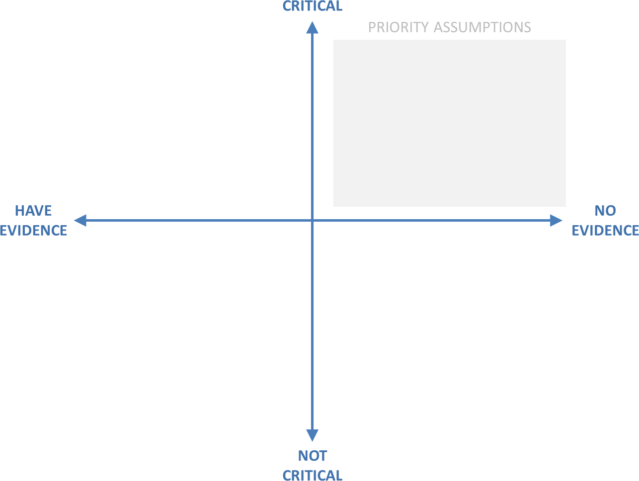

SET UP TIME TO MEET WITH YOUR COACH, THEN GO ON TO THE NEXT VIDEO

# Interview Question Worksheet

Use with [Step 2: Interview potential customers: Part 1: Figure out what to ask](https://www.youtube.com/watch?v=GXtbM6Wg8Do&list=PLFbxF_Ln4MnfkpScj3_5RvtRPU-JUhGBf&index=4)

DIRECTIONS: Use this worksheet to generate a list of interview questions to help you validate or invalidate the critical assumptions you identified using the Prioritization Matrix on the previous page. Remember to write open-ended questions with neutral tone and language. Focus on learning about your potential

customer’s current behaviors. In the worksheet below, list the business assumption you wish to test in the left column, and the interview questions that will help you test that assumption in the right column.

Remember you should be digging deeper by asking “why” or “tell me more”.

|  |  |
| --- | --- |
| Assumptions you want to test | Interview Questions |
| *Example: I think construction managers may be looking for a better way to schedule shift workers* | *Tell me about how you currently schedule shift workers* |
| 1. |  |
| 2. |  |
| 3. |  |
| 4. |  |
| 5. |  |
| 6. |  |
| 7. |  |
| 8. |  |
| 9. |  |
| 10. |  |

SET UP TIME TO MEET WITH YOUR COACH, THEN GO ON TO THE NEXT VIDEO

# Interview Preparation Worksheet

With video [Step 2: Interview potential customers: Part 2: Find people to interview](https://www.youtube.com/watch?v=QwTlwHsDOQU&list=PLFbxF_Ln4MnfkpScj3_5RvtRPU-JUhGBf&index=5&pp=iAQB)

DIRECTIONS: Use the chart below to figure out where and how to find people to interview who fit your target customer profile, and to plan how you will reach out and interview them. Consider these tips as you get ready.

* Tell interviewees that you want to interview them because they have related experience or interest(s) to a project you are working on. The more specific you can be about the request, the more likely that someone will say “yes”.
* Tell them that you aren’t selling anything but just looking to get their insights and opinions. Assure them that their identity and statements will be kept private.
* Give them information about the interview, like how long it will take and if it will be live or via video conference.
* Provide a list of times and dates that might work, especially important if you are reaching out via email.

|  |  |  |
| --- | --- | --- |
| WHERE: Places you might find customers, physically and virtually. | WHO: People who fit customer profile/ can connect you to others who do | HOW: Plan for who you will reach out to and how you plan to interview them |
| ***Example: Stores that sell model train products, online forums, websites and social media communities, influencers and experts, conferences, and events*** | *Model train collectors: shoppers and clerks at model train stores; members of model train social media groups; social media influencers; attendees of model train conferences* | *Hang out at model train store and attend a conference - strike up conversations with people there; look for contacts top interview in model train social media*  *groups; request interviews from online influencers* |
|  |  |  |
|  |  |  |
|  |  |  |
|  |  |  |
|  |  |  |
|  |  |  |
|  |  |  |
|  |  |  |
|  |  |  |
|  |  |  |

SET UP TIME TO MEET WITH YOUR COACH, THEN GO ON TO THE NEXT VIDEO

# Validating Assumptions Worksheet

With videos [Step 3: Analyze customer feedback: Part 1: Preparing your data](https://www.youtube.com/watch?v=6x1uUTTabBg&list=PLFbxF_Ln4MnfkpScj3_5RvtRPU-JUhGBf&index=7&pp=iAQB), Ste[p 3: Analyze customer](https://www.youtube.com/watch?v=1wi8Dcm7hK0&list=PLFbxF_Ln4MnfkpScj3_5RvtRPU-JUhGBf&index=8&pp=iAQB) [feedback: Part 2: Identify themes and patterns](https://www.youtube.com/watch?v=1wi8Dcm7hK0&list=PLFbxF_Ln4MnfkpScj3_5RvtRPU-JUhGBf&index=8&pp=iAQB) and [Step 3: Analyze customer feedback: Part 3:](https://www.youtube.com/watch?v=iOlHOg6Z5QM&list=PLFbxF_Ln4MnfkpScj3_5RvtRPU-JUhGBf&index=9&pp=iAQB) [Validate/invalidate your assumptions](https://www.youtube.com/watch?v=iOlHOg6Z5QM&list=PLFbxF_Ln4MnfkpScj3_5RvtRPU-JUhGBf&index=9&pp=iAQB)

DIRECTIONS: Use the chart below to organize your interview nuggets into themes and sub-themes. Then, identify which assumptions, if any, have been validated or invalidated. Use additional paper if needed.

**ACTIVITY 1:** Begin by identifying themes and sub-themes within your nuggets.

1. List your key nuggets in the first column.
2. Look for patterns or themes and use the second column to label that theme.
3. Look for sub-themes, or additional patterns embedded within them and use the third column to label that sub-theme.

|  |  |  |
| --- | --- | --- |
| ACTIVITY 1 | | |
| Nugget | Theme | Sub-theme |
| *Example: It’s hard to eat healthy because I’m so busy* | *Barriers to eating healthy* | *Lack of time* |
|  |  |  |
|  |  |  |
|  |  |  |
|  |  |  |
|  |  |  |
|  |  |  |
|  |  |  |
|  |  |  |
|  |  |  |
|  |  |  |
|  |  |  |

GO ON TO THE NEXT VIDEO

# Validating Assumptions Worksheet, cont.

ACTIVITY 2: Align customer discovery insights with critical assumptions.

* 1. In the first column list the number of the assumption you were testing based on your Interview Question Worksheet you previously completed.
  2. In the second column make notes on what customers said about that assumption.
  3. For each assumption indicate whether it was Validated (V), Invalidated (I), or you need more info

(N). (Note: you might not have enough information yet to validate assumptions—that’s OK!)

* 1. Make notes on any new assumptions you now have and next steps needed to gather more

information or assumptions you weren’t able to validate or invalidate.

|  |  |  |  |  |
| --- | --- | --- | --- | --- |
| ACTIVITY 2 | | | | |
| Assumption | Customer  discovery learnings | Validated, Invalidated, or  Need more info? | New assumptions | Next steps |
|  |  |  |  |  |
|  |  |  |  |  |
|  |  |  |  |  |
|  |  |  |  |  |
|  |  |  |  |  |
|  |  |  |  |  |
|  |  |  |  |  |
|  |  |  |  |  |
|  |  |  |  |  |
|  |  |  |  |  |
|  |  |  |  |  |
|  |  |  |  |  |

SET UP TIME TO MEET WITH YOUR COACH, THEN GO ON TO THE NEXT VIDEO

# Jobs to Be Done Worksheet

With video [Step 4: Define who, what, and why: Part 1: Craft a Job to be Done statement](https://www.youtube.com/watch?v=pX4tOuYinYk&list=PLFbxF_Ln4MnfkpScj3_5RvtRPU-JUhGBf&index=10&pp=iAQB)

DIRECTIONS: Review your nuggets and validated assumptions, then draft at least 5 possible Jobs to be Done statements using the suggested format below. Decide which most clearly and succinctly captures what you are learning.

|  |  |  |  |
| --- | --- | --- | --- |
| JOBS TO BE DONE EXAMPLE | | |  |
| “I am…” (include at least 3 customer characteristics) | “I am trying to…” (the  outcome of job they are trying to do) | “But…” (the problem or  challenge preventing them from getting the job done) | “Because…” (the root cause of why the problem is happening) |
| *I am a working mother of 2 active kids who participate in competitive sports year round.* | *I am trying to eat*  *healthier because I don’t*  *have time to exercise,* | *but on-the go options aren’t very healthy, and I don’t have time to plan, shop, and make healthy meals myself,* | *because I can’t shop during work hours and after work I have to drive my kids to and from different practices, plus my cooking skills*  *aren’t that great anyway.* |

|  |  |  |  |
| --- | --- | --- | --- |
| JOBS TO BE DONE - DRAFT 1 | | |  |
| “I am…” | “I am trying to…” | “But…” | “Because…” |
|  |  |  |  |

|  |  |  |  |
| --- | --- | --- | --- |
| JOBS TO BE DONE—DRAFT 2 | | |  |
| “I am…” | “I am trying to…” | “But…” | “Because…” |
|  |  |  |  |

|  |  |  |  |
| --- | --- | --- | --- |
| JOBS TO BE DONE – DRAFT 3 | | |  |
| “I am…” | “I am trying to…” | “But…” | “Because…” |
|  |  |  |  |

|  |  |  |  |
| --- | --- | --- | --- |
| JOBS TO BE DONE – DRAFT 4 | | |  |
| “I am…” | “I am trying to…” | “But…” | “Because…” |
|  |  |  |  |

|  |  |  |  |
| --- | --- | --- | --- |
| JOBS TO BE DONE – DRAFT 5 | | |  |
| “I am…” | “I am trying to…” | “But…” | “Because…” |
|  |  |  |  |

GO ON TO THE NEXT VIDEO

# Customer Personas Worksheet

With video [Step 4: Define who, what, and why: Part 2: Build customer personas](https://www.youtube.com/watch?v=1Sptu5HfhE0&list=PLFbxF_Ln4MnfkpScj3_5RvtRPU-JUhGBf&index=11&pp=iAQB)

DIRECTIONS: Now that you’ve learned more about your customer through customer discovery, the next step is to create one persona per customer segment. Use all the insights you’ve learned about the segment to complete the customer persona chart below. If you have more than one customer segment, complete additional personas.

CUSTOMER PERSONA EXAMPLE

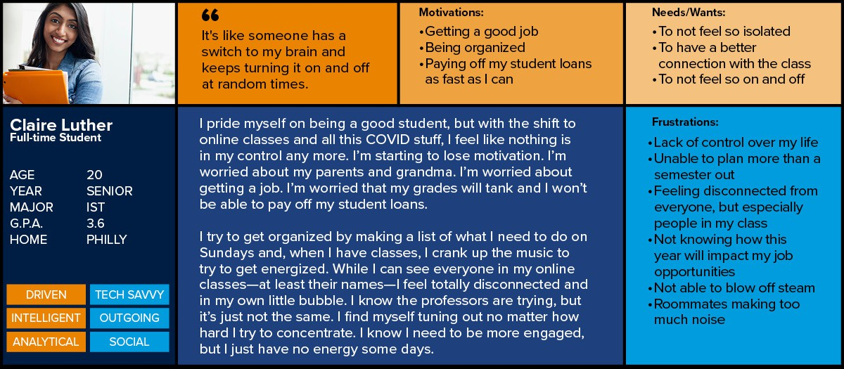

|  |  |  |
| --- | --- | --- |
|  | CUSTOMER PERSONA | |
| Name |  |
| Demographics & personality  traits |  |
| Quote about the need or problem  Paste  Image  here | |  |
| Common Motivations | |  |
| Specific Needs or Wants | |  |
| Frustrations | |  |
| Day in the Life Narrative | |  |

SET UP TIME TO MEET WITH YOUR COACH, THEN GO ON TO THE NEXT VIDEO

Insert Customer Photo

Here

# Competitive Landscape Worksheet

With video [Step 4: Define who, what, and why: Part 3: Define competitors’ value](https://www.youtube.com/watch?v=K6bbh4DLTWM&list=PLFbxF_Ln4MnfkpScj3_5RvtRPU-JUhGBf&index=12)

DIRECTIONS: Yes, you do have competition! Learning more about your competitors will help you serve your customer better. The chart below will help you analyze your competitive landscape. Enter the following for each competitor:

1. Company Name**.** Look through your customer discovery interview notes—how are your customers trying to solve their problem now? Do an Internet search on the problem or need to see what companies come up. Think through your own experience with potential solutions. Brainstorm how else your customer might solve their problem.
2. **Value** they provide**.** For each competitor, list the value they claim to provide in column 2. “Value” refers to the way they solve the customer problem. Check the competitor website, marketing, and sales materials for ideas.
3. **Benefits**. How *specifically* does each competitor’s product/service solve the customer problem or need?
4. **Pricing model**. How does each collect money from customers (e.g. transaction, subscriptions, freemium, etc.)? What are the actual price points?
5. **How customers acquire the solution**. How does product/service fulfillment work? How does the customer access or receive the solution?
6. **What others are saying.** What do customers say about the competition—both the solution and the company? What do other competitors say? Capture both the good and the bad. Look for reviews, blogs, etc.
7. **Marketing message.** How does the competitor talk about its solution in its marketing? This will help you better understand the competitor’s target market, the value proposition, sales approach, and marketing strategy.
8. **Your experience with the solution.** Experience the competitor’s solution directly—try their product or service. Note your end-to-end experience, from shopping to receiving to using the solution.

|  |  |  |  |  |  |  |  |
| --- | --- | --- | --- | --- | --- | --- | --- |
| COMPETITIVE LANDSCAPE | | | | | | | |
| Company Name | Value they provide | Benefits | Pricing model | How customers receive their solution | What others are saying about them | Marketing message | Your experience |
|  |  |  |  |  |  |  |  |
|  |  |  |  |  |  |  |  |
|  |  |  |  |  |  |  |  |
|  |  |  |  |  |  |  |  |
|  |  |  |  |  |  |  |  |
|  |  |  |  |  |  |  |  |
|  |  |  |  |  |  |  |  |
|  |  |  |  |  |  |  |  |
|  |  |  |  |  |  |  |  |
|  |  |  |  |  |  |  |  |
|  |  |  |  |  |  |  |  |

GO ON TO THE NEXT VIDEO

# Value Proposition Statement Worksheet

With video [Step 4: Define who, what, and why: Part 4: Define your value proposition](https://www.youtube.com/watch?v=zg2pLcDy1Ss&list=PLFbxF_Ln4MnfkpScj3_5RvtRPU-JUhGBf&index=13&pp=iAQB)

DIRECTIONS: A clear value proposition is the basis of your elevator speech and is a critical step in communicating the value of what you offer to your customer. Though value proposition statements are written in a narrative/sentence form, the first step is to identify the four main components included in a good value proposition: the pain, the gain, the what, and the why.

It’s time to draft a few possible value proposition statements for your solution. Once you’ve created a few options,

we suggest that you review them with your coach.

|  |  |  |  |
| --- | --- | --- | --- |
| VALUE PROPOSITION STATEMENT - EXAMPLE | | |  |
| Pain (the problem or  need that your customer has) | Gain (the benefit or what the  customer gets from your solution) | What (succinct explanation of  your solution or what you do for them) | Why (the differentiator or why the  customer should buy from you over others) |
| *For pet owners who never want to lose track of their much-loved pet* | *FriendChip enables vets and animal shelters to return lost pets to their owners* | *FriendChip is a device the size of a grain of sand, placed under the skin, which transmits a unique identification number”.* | *Unlike traditional collar tags, FriendChip provides safe, permanent, and reliable identification of your pet.* |

|  |  |  |  |
| --- | --- | --- | --- |
| VALUE PROPOSITION STATEMENT – DRAFT 1 | | |  |
| Pain | Gain | What | Why |
|  |  |  |  |

|  |  |  |  |
| --- | --- | --- | --- |
| VALUE PROPOSITION STATEMENT – DRAFT 2 | | |  |
| Pain | Gain | What | Why |
|  |  |  |  |

|  |  |  |  |
| --- | --- | --- | --- |
| VALUE PROPOSITION STATEMENT – DRAFT 3 | | |  |
| Pain | Gain | What | Why |
|  |  |  |  |

SET UP TIME TO MEET WITH YOUR COACH

THIS ISN’T GOODBYE.

Congratulations on completing the Customer Discovery 101 program. We hope that you have found the program helpful as you test and build your business idea.

This isn’t the end of the road! As you’ve learned in the program, customer discovery is a vital process that businesses use continuously to help inform important business decisions. We encourage you to use customer discovery anytime you need to learn more about current or potential customers; that might include when customer behaviors change, when new competition enters the market, when you want to target new markets, and of course, when you are developing new products or services.

We also encourage you to maintain and expand your network. Check out free and low-cost services offered by [PA Small Business Development Centers,](https://www.pasbdc.org/) [SCORE,](https://www.score.org/) and [Ben Franklin Technology Partners.](https://benfranklin.org/)

If you haven’t connected with a LaunchBox or innovation space, you can locate the nearest one [here](https://invent.psu.edu/programs/pa-innovation-hubs/) or email [customerdiscovery@psu.edu.](mailto:customerdiscovery@psu.edu) Each Innovation Space offers free and low-cost coaching, startup programs, free legal help, and other useful resources as you continue building your business.

Interested in doing customer discovery in a group or class setting? Consider joining an *Idea TestLab* accelerator program, offered by most LaunchBoxes and innovation spaces in the Invent Penn State Network (see example [here).](https://happyvalley.launchbox.psu.edu/idea-testlab/) Contact your local innovation space to learn more.

## Thanks for participating in the Customer Discovery 101 program!

We want your feedback. Please take this anonymous survey to help us make this program better. [Click here to take the survey](https://bit.ly/customerdiscoverysurvey) or enter https://bit.ly/customerdiscoverysurvey.

This publication is available in alternate media upon request. Penn State is an equal opportunity, affirmative action employer, and is committed to providing employment opportunities to all qualified applicants without regard to race, color, religion, age, sex, sexual orientation, gender identity, national origin, disability or protected veteran status.